Capstone Project: Full Incident Response Cycle

1. Executive Summary
A simulated cyber attack was conducted using Metasploit to exploit a vulnerability in the VSFTPD service on a Metasploitable2 system. The attack demonstrated how attackers can gain unauthorized access to a vulnerable system. Detection was attempted using Wazuh, and containment was implemented using firewall-based controls. The incident was successfully managed through all stages of the incident response lifecycle.

2. Attack Simulation
The attack was performed using the Metasploit framework with the module exploit/unix/ftp/vsftpd_234_backdoor. The exploit successfully triggered a backdoor, allowing remote access to the target system.

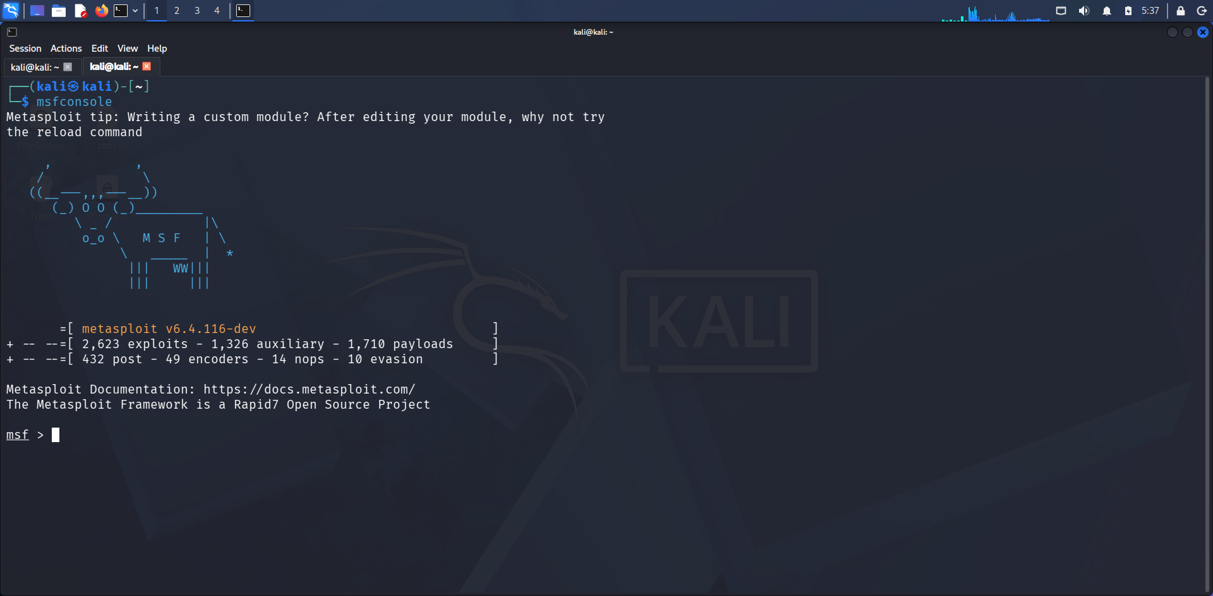
3. Detection
Monitoring was performed using Wazuh. Due to the absence of an agent on the target system, the attack was not directly logged. However, based on observed activity, the event was identified as a VSFTPD exploit attempt.
Timestamp | Source IP | Alert Description | MITRE Technique
2026-04-27 | 192.168.56.103 | VSFTPD exploit attempt detected | T1190
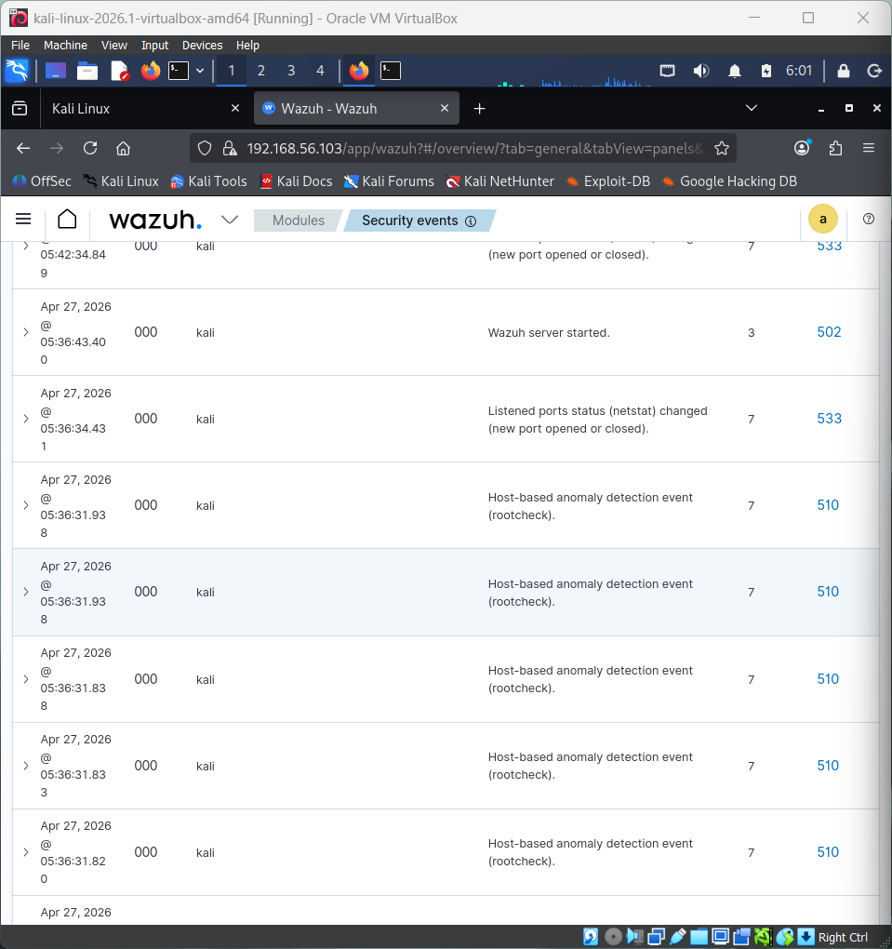

4. Containment
Due to compatibility limitations with Kali Linux, CrowdSec could not be deployed. Instead, containment was achieved using iptables firewall rules. The attacker IP address was blocked to prevent further access attempts.
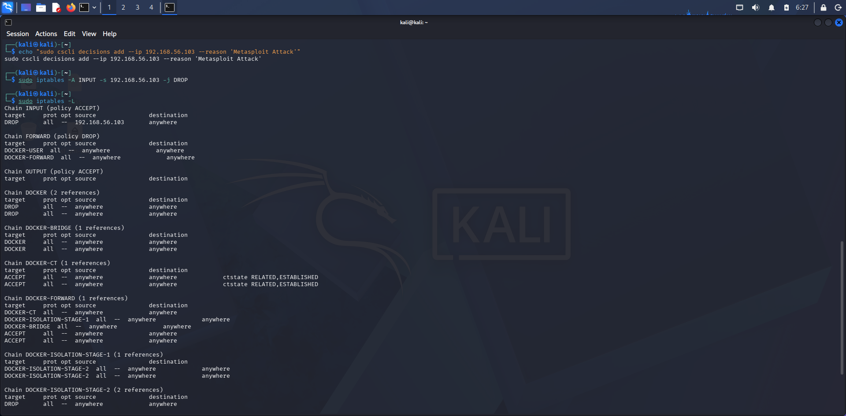
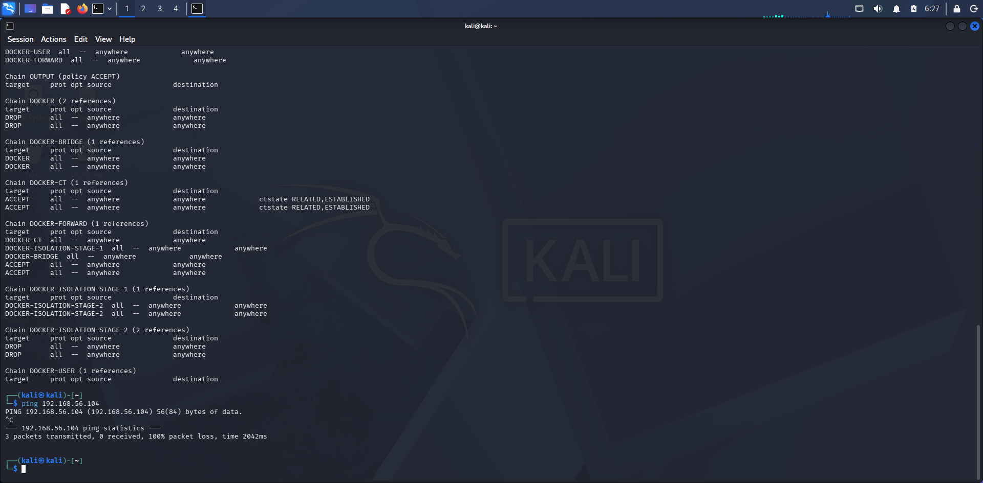

5. Recovery
The affected system was analyzed and no persistent compromise was found. Normal operations were restored after ensuring the system was secure.

6. Recommendations
- Regularly patch vulnerable services
- Deploy endpoint monitoring agents
- Implement intrusion detection systems
- Use firewall rules to block malicious IPs
- Conduct regular security testing

